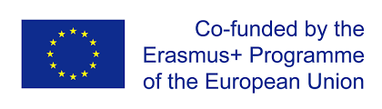 | ERASMUS KA219  „The European Child: Learning by doing the 3 C's- Connect, Construct and Create”  Transnational project meeting in England  17. 04. 2018 - 21.04. 2018. | 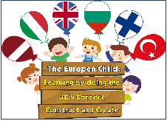

Participants: one from each organization (together 6)
During the international meeting, there will be a feedback on the project, an assessment and evaluation of its objectives and targets achievements so that all of us can redefine, reorganize or repeat activities that did not achieve their goals.

We will talk about:
1. The dissemination of the project results in the long term,
2. Budget and time management.
3. Creating the E-twinning project.
4. Creating educational material: „Nature Scrapbook”, ” The Art DVD”, “I am an Artist”.
5. Approbation/ testing of the experience of „Child of Nature” in each country (only discussions).

6.All partners will report about project implementation during the first learning year: time management (activities), implementation, benefits, dissemination of results.
7.Planning second year of project. We will discuss about teaching/ learning activities which are 'One child, TWO languages”, 'ROBOTİNG CODE' .
8. We will attend lessons and watch teachers working with children, art classes, non-traditional activities.

Mara, Latvia

