Title of activity | The magic of rainbow and rain/Summer trip/  Suitable for performance by children of all ages
Environment, materials | Outdoors in the courtyard of the kindergarten during the sunny summer days.  Materials: garden hose, sun and water.
Teacher's support for the child | Teacher and children water the trees and flowers in the yard of the kindergarten using a garden hose.  The teacher asks the children whether they have seen a rainbow close and when the rainbow appears.  Helps children reveal the secret of the rainbow by standing with their backs to the sun and directing the flow of water from the garden hose to a wall or fence.  Teacher shows amazement and joy from the appearance of a rainbow.
Expected result | On a practical basis observing, the children learn that light is not white but consists of colors. They also find that the rainbow appears with a help of the rain, and when the rays of the sun meet the water drops, the rainbow colors appear.  Children are excited about the rainbow and learn how many are the colors of the rainbow and which they are.  Children are happy to cool off during hot summer days and understand how important rain is for all living creatures.  Children think games with the water accumulated in the puddles after rain.
Children's activities (planning, tasks, evaluation) | The children observe the appearance of the rainbow. The number of their colors, their sequence. Every child can participate in the games with water and make a rainbow - they fill plastic cups with water, place them on a white sheet of a window through which the sun shines. When the sun is strong, a small rainbow appears on the sheet.  Kids draw the rainbow.  Where a great puddle arose after “The rain”, children collect and place a lot of stones to make a bridge through which they pass.
Attachment ( foto, video) | 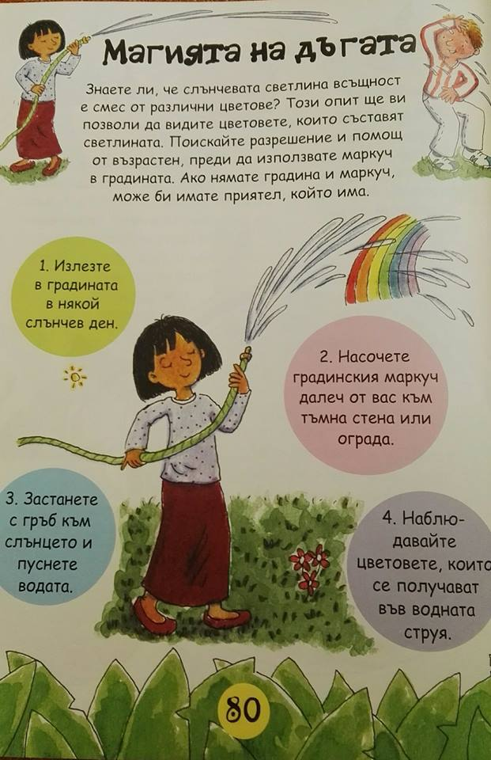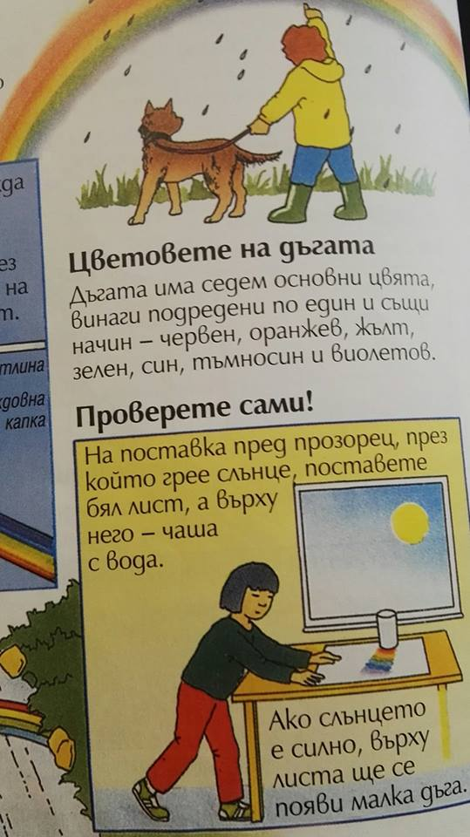
Looking for answers to the questions | Where is the rainbow?  With what's up?  How many are the colors of the rainbow?  What are the colors of the rainbow?  Can we get it?  What is the weather today? Which season is it?  Why is the rain so important? For what, for whom?  What games can you figure out after rain?  Where do the water drops from?
Source of information:,,Наука в градината”, Изд. ,,Фют’’ 2010
At home with science dig and sow,
Published by arrangement with Kingfisher Publications plc

