Title of activity | A little lake in the kindergarten/Spring trip – planting and research /  Age: 5 – 7 years old children
Environment, materials | Outside, at the kindergarten’ territory.  Materials: old basin - about 40 cm wide and about 25 cm deep, sand, several flat stones and several more larger river stones, water, bigger shovel for the teacher and smaller for the kids, one or two aquatic plants
Teacher's support for the child | The teacher is enthusiastic about the idea of children to make a lake in the kindergarten.  The teacher chooses a place that is moderately shining from the sun and provides the necessary material for it.  The teacher helps the children to dig a hole in which they will place the basin.  The teacher watches the children while arranging the stones around the lake.  The teacher works with the children.
Expected result | Children learn how to make a home lake in the kindergarten and find that they can use old stuff for the purpose. Children are happy to be able to take care and grow aquatic plants in the lake.  After building the lake and filling it with water, children can watch the insects and animals that will appear - waterfowl, frog, butterflies, snails, birds to drink water, and understand how important it is to all living beings.  Children take care of the cleanliness of the lake daily and realize the need of care for nature.
Children's activities (planning, tasks, evaluation) | The children put the basin on the ground and outline the place around it, cut a hole as big as the basin and place it inside. Sand out in it. They flatten the flat stones along the edge of the basement and the bigger ones inside. Finally pour water / can wait for a rainy day, during which the small lake will be filled with water /.Children arrange the lake with twigs and aquatic plants. Children are much happy of the result and every day observe the plants and animals around the lake.
Attachment ( foto, video) | 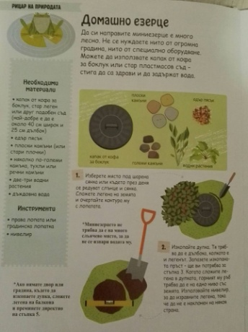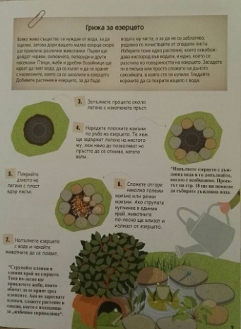
Looking for answers to the questions | What do we need to make an homemade lake?  Why do we use shovels?  Why do we arrange the flat stones on the edge of the basin?  How did we fill the lake?  What kinds of animals are coming? What are the wings of the waterfront, Where does the snail crawl, What sounds the frog does, What birds did you see?  The humans and animals cannot live without…… ?  Why do we clean the lake from the leaves fallen on the water?  Why did we build the lake at the shadow place?
Source of information: ,,23 Ways to be an Eco Hero’’
Marshall Editions 2015

