Title of activity  “I am an Artist” | Paintings with colorful pieces of ice.
Age for children | 3-7 ages
Environment, materials | Ruffle, cotton buds, gouache colors
Expected result | Children have learned new drawing techniques .. Children love to get to know and draw with different materials  Imagine practical application for paintings with ice pieces.
Teacher's support for the child | Teacher tells children that they can draw using different colors, even frozen.
Children's activities (planning, tasks, evaluation) | The children prepare with the teacher for color-freezing.  When colored frozen children act freely, they draw colored paintings after their intentions.
Looking for answers to questions | The children prepare with the teacher for color-freezing.  When colored frozen children act freely, they draw colored paintings after their intentions.
Attachment ( foto, video) 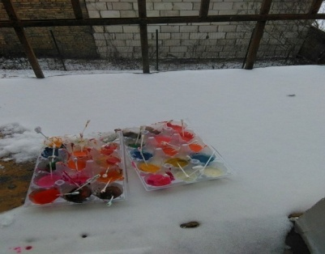 | 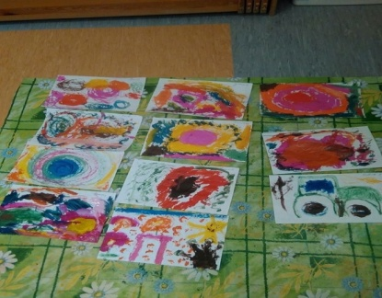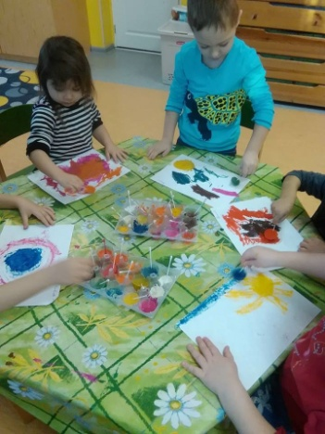
Author Ineta Tone, SPII “Valodina”, Dobele, Latvia

