Title of activity | Paintings on stones
Age for children | 4-7 years
Environment, materials | Gouache paints, PVA glue, various brushes, various stones, a bowl of water.
Teacher's support for the child | Teacher looks at stones of different sizes and asks the children – what might be similar to each stone. Teacher paints stone like a moon, while children watch and engage in drawing on stones.
Expected result | Children know that they can draw not only on pages, but also on different subjects. It is pleasure for the work what is done. Children have been mastered new drawing techniques. Marked stones can be used in plays or in counting
Children's activities (planning, tasks, evaluation) | Children prepare for work – take paints, PVA glue, brushes, pour water into a bowl, take stones. Found out what the stones look like and what could be on it. Mix color with glue. Paint stones – draw different subjects or animals.
Looking for answers to the questions | What can we use for drawing on stones?  Are all stones of the same size and shape?  What can we else draw on stones?  Where can we use painted stones?
Attachment ( foto, video) | 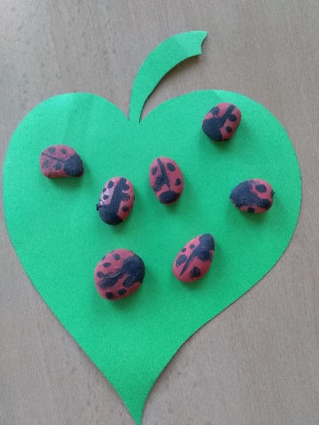  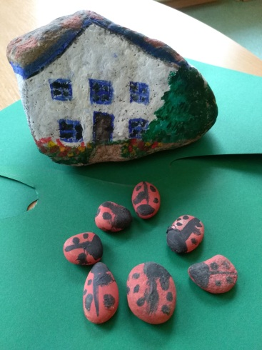
Author Daina Voitehoviča, SPII “Valodina”, Dobele, Latvia

