Title of activity | Painting with yarn
Age for children | 4-7 years
Environment, materials | Gouache paints, brush, painting page (folded to half) or two A4 format pages, different width and texture yarns, bowl with water.
Teacher's support for the child | Teacher tells and shows how to paint with different thick and texture yarns, put between pages and pull out yarn and watch what is got. Childrens are interested and watching how teacher is working.
Expected result | Childrens know that you can paint differently. They are happy about what is done. Childrens learned new painting technique. You can use many yarns in different colors in paintings with yarn.
Children's activities (planning, tasks, evaluation) | Childrens prepare for work - take paints, brush, pour water into a bowl, take a drawing sheet and pieces of different thick yarns. Fold a drawing page in half. Choose colors to work with. Brush the paint with a wet brush and paint the thread.  Childrens need the painted thread pour onto the flip-flops on one side of the folded leaf, then close the leaf. With one hand, easily hold a closed page and pull the thread out with the other hand. An drawing is created. You can also put a thread of other colors in it, creating different colored drawings.  When the paint dries, you can draw some sketchy drawing, note any objects, creatures or animals.
Looking for answers to the questions | What else we can draw with?  Why did you choose these pieces of yarn?  What colors do you like?  Why did you choose exactly these colors?  What came up on your page?
Attachment ( foto, video) | 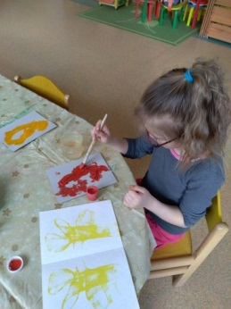  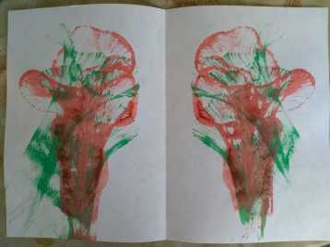  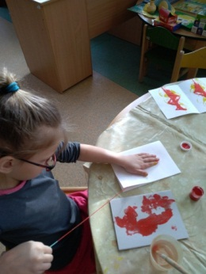  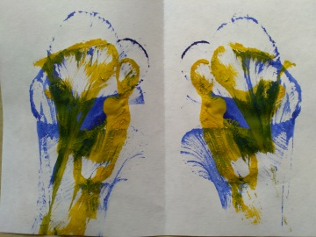  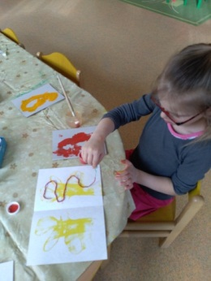
Author Daina Voitehoviča, SPII “Valodina”, Dobele, Latvia

