Title of activity | Children’s compass /Autumn trip-orienteering games /  Age 6-7 years old
Environment, materials | Outside, at the kindergarten territory, on trip in the forest. Materials - chalk for painting, signs showing directions east - sun, west - moon, north - snowflake, south – flower.
Teacher's support for the child | Teacher draws on the ground a circle with a diameter of 2-3 meters. Within the three to four meters of the circle, the teacher puts signs to determine four directions: east, west, north and south respectively, sun - east, moon - west, snowflake - north and flower - south.  Teacher invites children to choose a sign for a direction and they stand up in the middle of the circle.  Teacher says one direction, for example – north, everybody that have chosen snowflake go to the big snowflake on the North.  Teacher supports and encourages those who are not good at it, works together with children.
Expected result | Children learn more about relationships in the nature .  Children know the meaning of the symbols and to handle the directions freely.  Each child thinks about its choice and in which direction to go.  Children learn orienting according to the symbols.  Children orient themselves in other situation using symbols/signs.  Children learn that compass is connected with the direction and its meaning for people in nature environment.
Children's activities (planning, tasks, evaluation) | Children observe each sign that shows one direction.  Each child has possibility to make its own choice of direction and then can change the sign in next implementation of the game.  Children move according to some direction.
Attachment ( foto, video) | 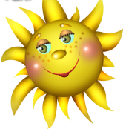East West North 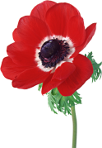South
Looking for answers to the questions | Why we use these signs?-connection between symbols and directions  Why we draw the circle? – the shape of the compass  Where is there more snow than other places?  Where is always hot? – on South – more sun warmth  Why we have to know the directions? – to know the right place when go to the forest, for example…..
Source of information: Internet https://diuu.bg/ispisanie/broi28/28dpp/28dpp9.pdf

